WEEK 1
Monday | Tuesday | Wednesday | Thursday | Friday
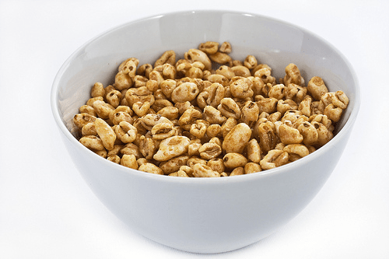  Breakfast  A selection of cereal  Toast  Fruit  with Cow’s/Coconut/Oak Milk | Breakfast  A selection of cereal  Toast  Fruit  with Cow’s/Coconut/Oak Milk | Breakfast  A selection of cereal  Toast  Fruit  with Cow’s/Coconut/Oak Milk | Breakfast  A selection of cereal  Toast  Fruit  with Cow’s/Coconut/Oak  Milk | Breakfast  A selection of cereal  Toast  Fruit  with Cow’s/Coconut/Oat Milk
Lunch  Broccoli & Vegetable Cheese Pasta Bake  Banana & Custard | Lunch  Quorn Pie with Butternut Squash & Potato Topping  Fruit Salad with  Crème Fraiche | Lunch  Chickpea & Vegetable Curry with Spinach & Rice  Cookie & Milk | Lunch  Turkey Bolognaise OR Quorn Bolognaise with Vegetables &  Tri-Colour Pasta  Sultana Sponge & Custard | Lunch  Fish Fingers,  Sweet Potato Chips & Peas  Rice Pudding
Tea  Pizza Crumpets  &  Cucumber Sticks | Tea  Leek & Potato Soup  Wholemeal Bread Roll | Tea  Soft Pitta Bread with Cream Cheese OR Pate  &  Carrot Sticks | Tea  Salmon Balls with Beans | Tea  Soft Pitta Pockets with  Cheese OR Beans
Monday | Tuesday | Wednesday | Thursday | Friday
Breakfast  A selection of cereal  Toast  Fruit  with Cow’s/Coconut/Oat Milk | Breakfast  A selection of cereal  Toast  Fruit  with Cow’s/Coconut/Oat Milk | Breakfast  A selection of cereal  Toast  Fruit  with Cow’s/Coconut/Oat  Milk | Breakfast  A selection of cereal  Toast  Fruit  with Cow’s/Coconut/Oat Milk | Breakfast  A selection of cereal  Toast  Fruit  with Cow’s/Coconut/Oat  Milk
Lunch  Cauliflower Medley  With Peas  Carrot & Pineapple Muffins | Lunch  Spicy Quorn in Sauce  With Rice & Green Beans  Semolina with Chocolate Sprinkles | Lunch  Roast Chicken Thighs Casserole  With Potato, Carrots & Cabbage  Gingerbread & Vanilla Sauce | Lunch  Quorn OR Ham, Sweetcorn Pasta Bake  With Mixed Vegetables  Muesli Bar with Milk | Lunch  Luxury Fish Pie  With Peas  Mandarin Jelly
Tea  Puff Pastry Pizza  With  Cucumber Sticks | Tea  Tuna Muffins | Tea  Stovie Layer bake with Potato, carrots & Turnips | Tea  Filled Croissants with Bacon, veggie Slice and Cheese Sauce | Tea  Salmon Cakes with  Avocado
WEEK 2

Monday | Tuesday | Wednesday | Thursday | Friday
Breakfast  A selection of cereal  Toast  Fruit  with Cow’s/Coconut/Oat Milk | Breakfast  A selection of cereal  Toast  Fruit  with Cow’s/Coconut/Oat Milk | Breakfast  A selection of cereal  Toast  Fruit  with Cow’s/Coconut/Oat Milk | Breakfast  A selection of cereal  Toast  Fruit  with Cow’s/Coconut/Oat Milk | Breakfast  A selection of cereal  Toast  Fruit  with Cow’s/Coconut/Oat Milk
Lunch  Spaghetti Primavera  With Diced Carrots & Swede  Chocolate Vegan Cake | Lunch  Sweet Potato Whirls  With Couscous & Farmhouse Vegetables  Iced Sponge | Lunch  Quorn OR Chicken  Sweet and sour  With Carrots & Peas  Fruit Flapjack | Lunch  Vegetable OR Beef Moussaka  With Vegetables  Fruit Cake & Milk | Lunch  Salmon & Pea Risotto  With Broccoli  Dorset Biscuit
Tea  Bread Sticks with Garlic bean Dips  Fruit salad | Tea  Vegetable Goulash  With Wholemeal Roll | Tea  Vegetable Soup  With Muffins | Tea  Cheese & Mushroom Potato Cake | Tea  Mixed Sandwiches  & Pumpkin Muffin
WEEK 3

