

Walton Montessori Nursery Newsletter
(9/01/2020)

Oak Class
We have been so excited to return to nursery to see all our friends and tell them all the things we have been doing whilst we were on our Christmas break. We have been discussing some of the new toys that we received, and it’s been lovely to see the excitement as they tell their friends about their new Ice cream truck, Barbie or Garbage truck – to name just a few! We have been making books to display our Christmas Photos and it looks like everyone has had an amazing Festive period with their families.
We have also been talking to the children about the new classroom that we will soon be moving into – some of them have had a sneak preview and were very interested in all the new equipment that has begun to arrive in anticipation of our move.
We have also decided we want to help Teresa with making our own sandwiches and wraps for tea, we have discussed healthy and unhealthy foods and enjoyed being very independent! We have welcomed some new friends this week and are enjoying getting to know Leo, Roxana and Oona.

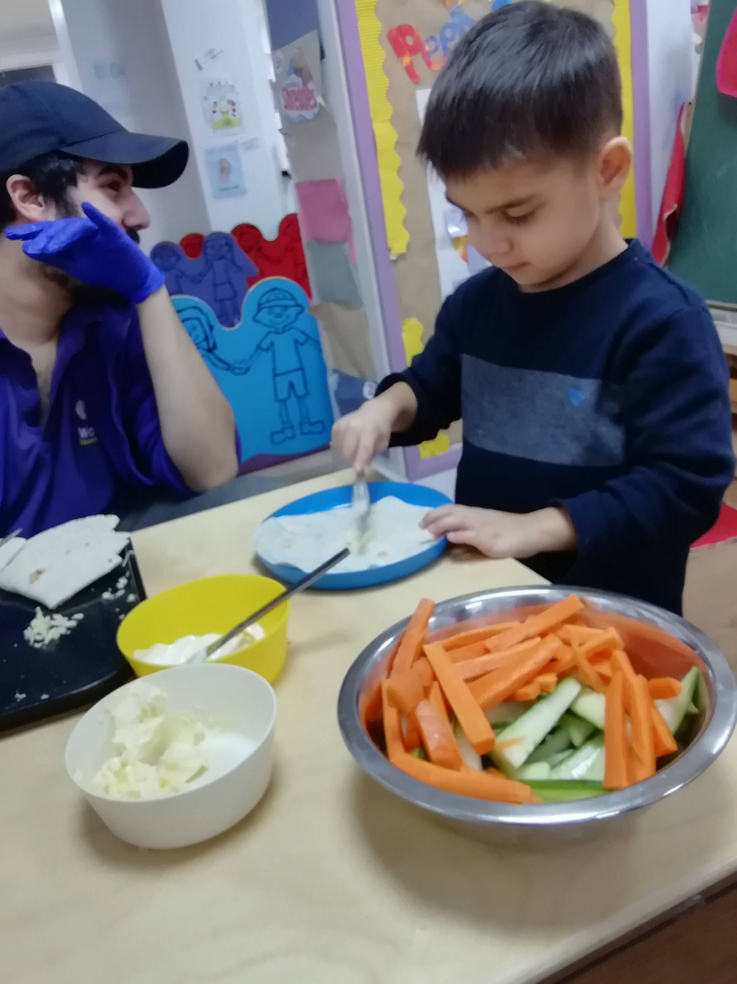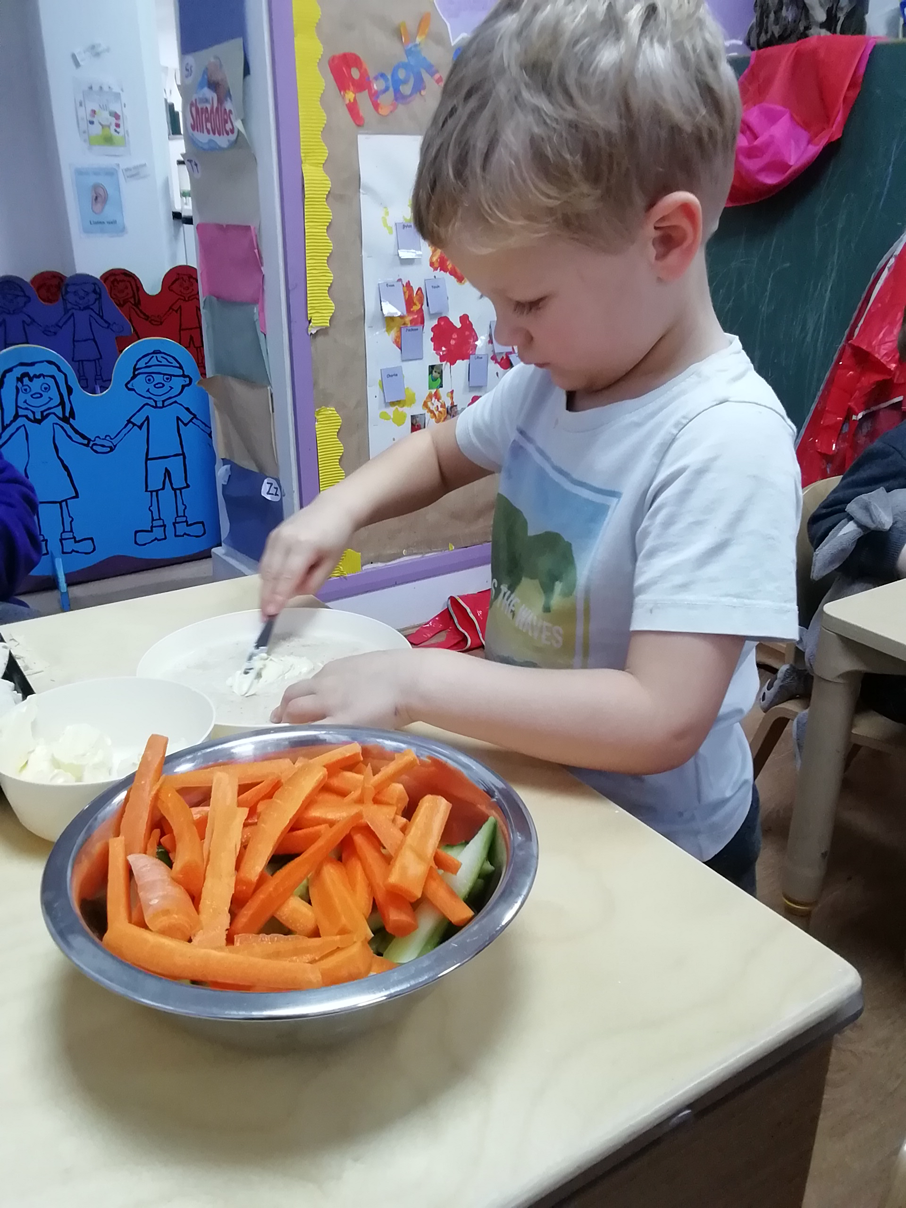

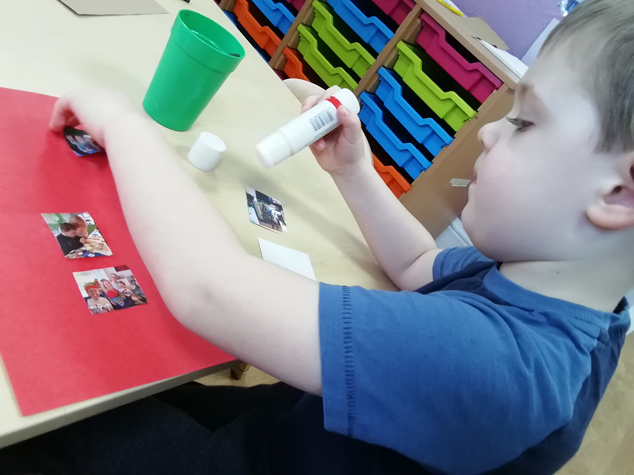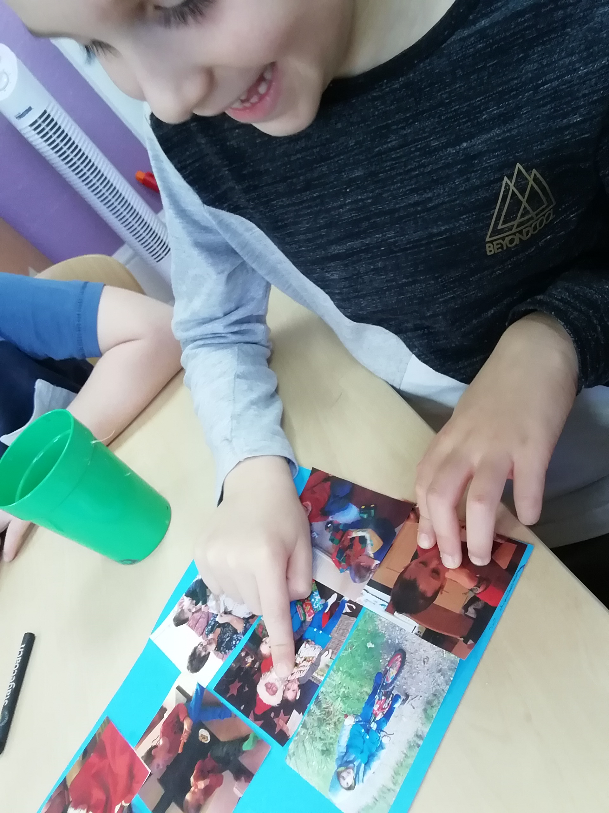

Elm Class
We have enjoyed our festive break but are keen to be back with our friends and exploring our environment.
We have really started to have lots of interest in books – turning the page, looking at pictures and getting excited when recognising familiar characters such as Peppa Pig etc.
We have also been getting wet with some water play and exploring what happens when things get wet!
We have welcomed our new friend Sienna for some introductory visits and are looking forward to her joining us in a few weeks.

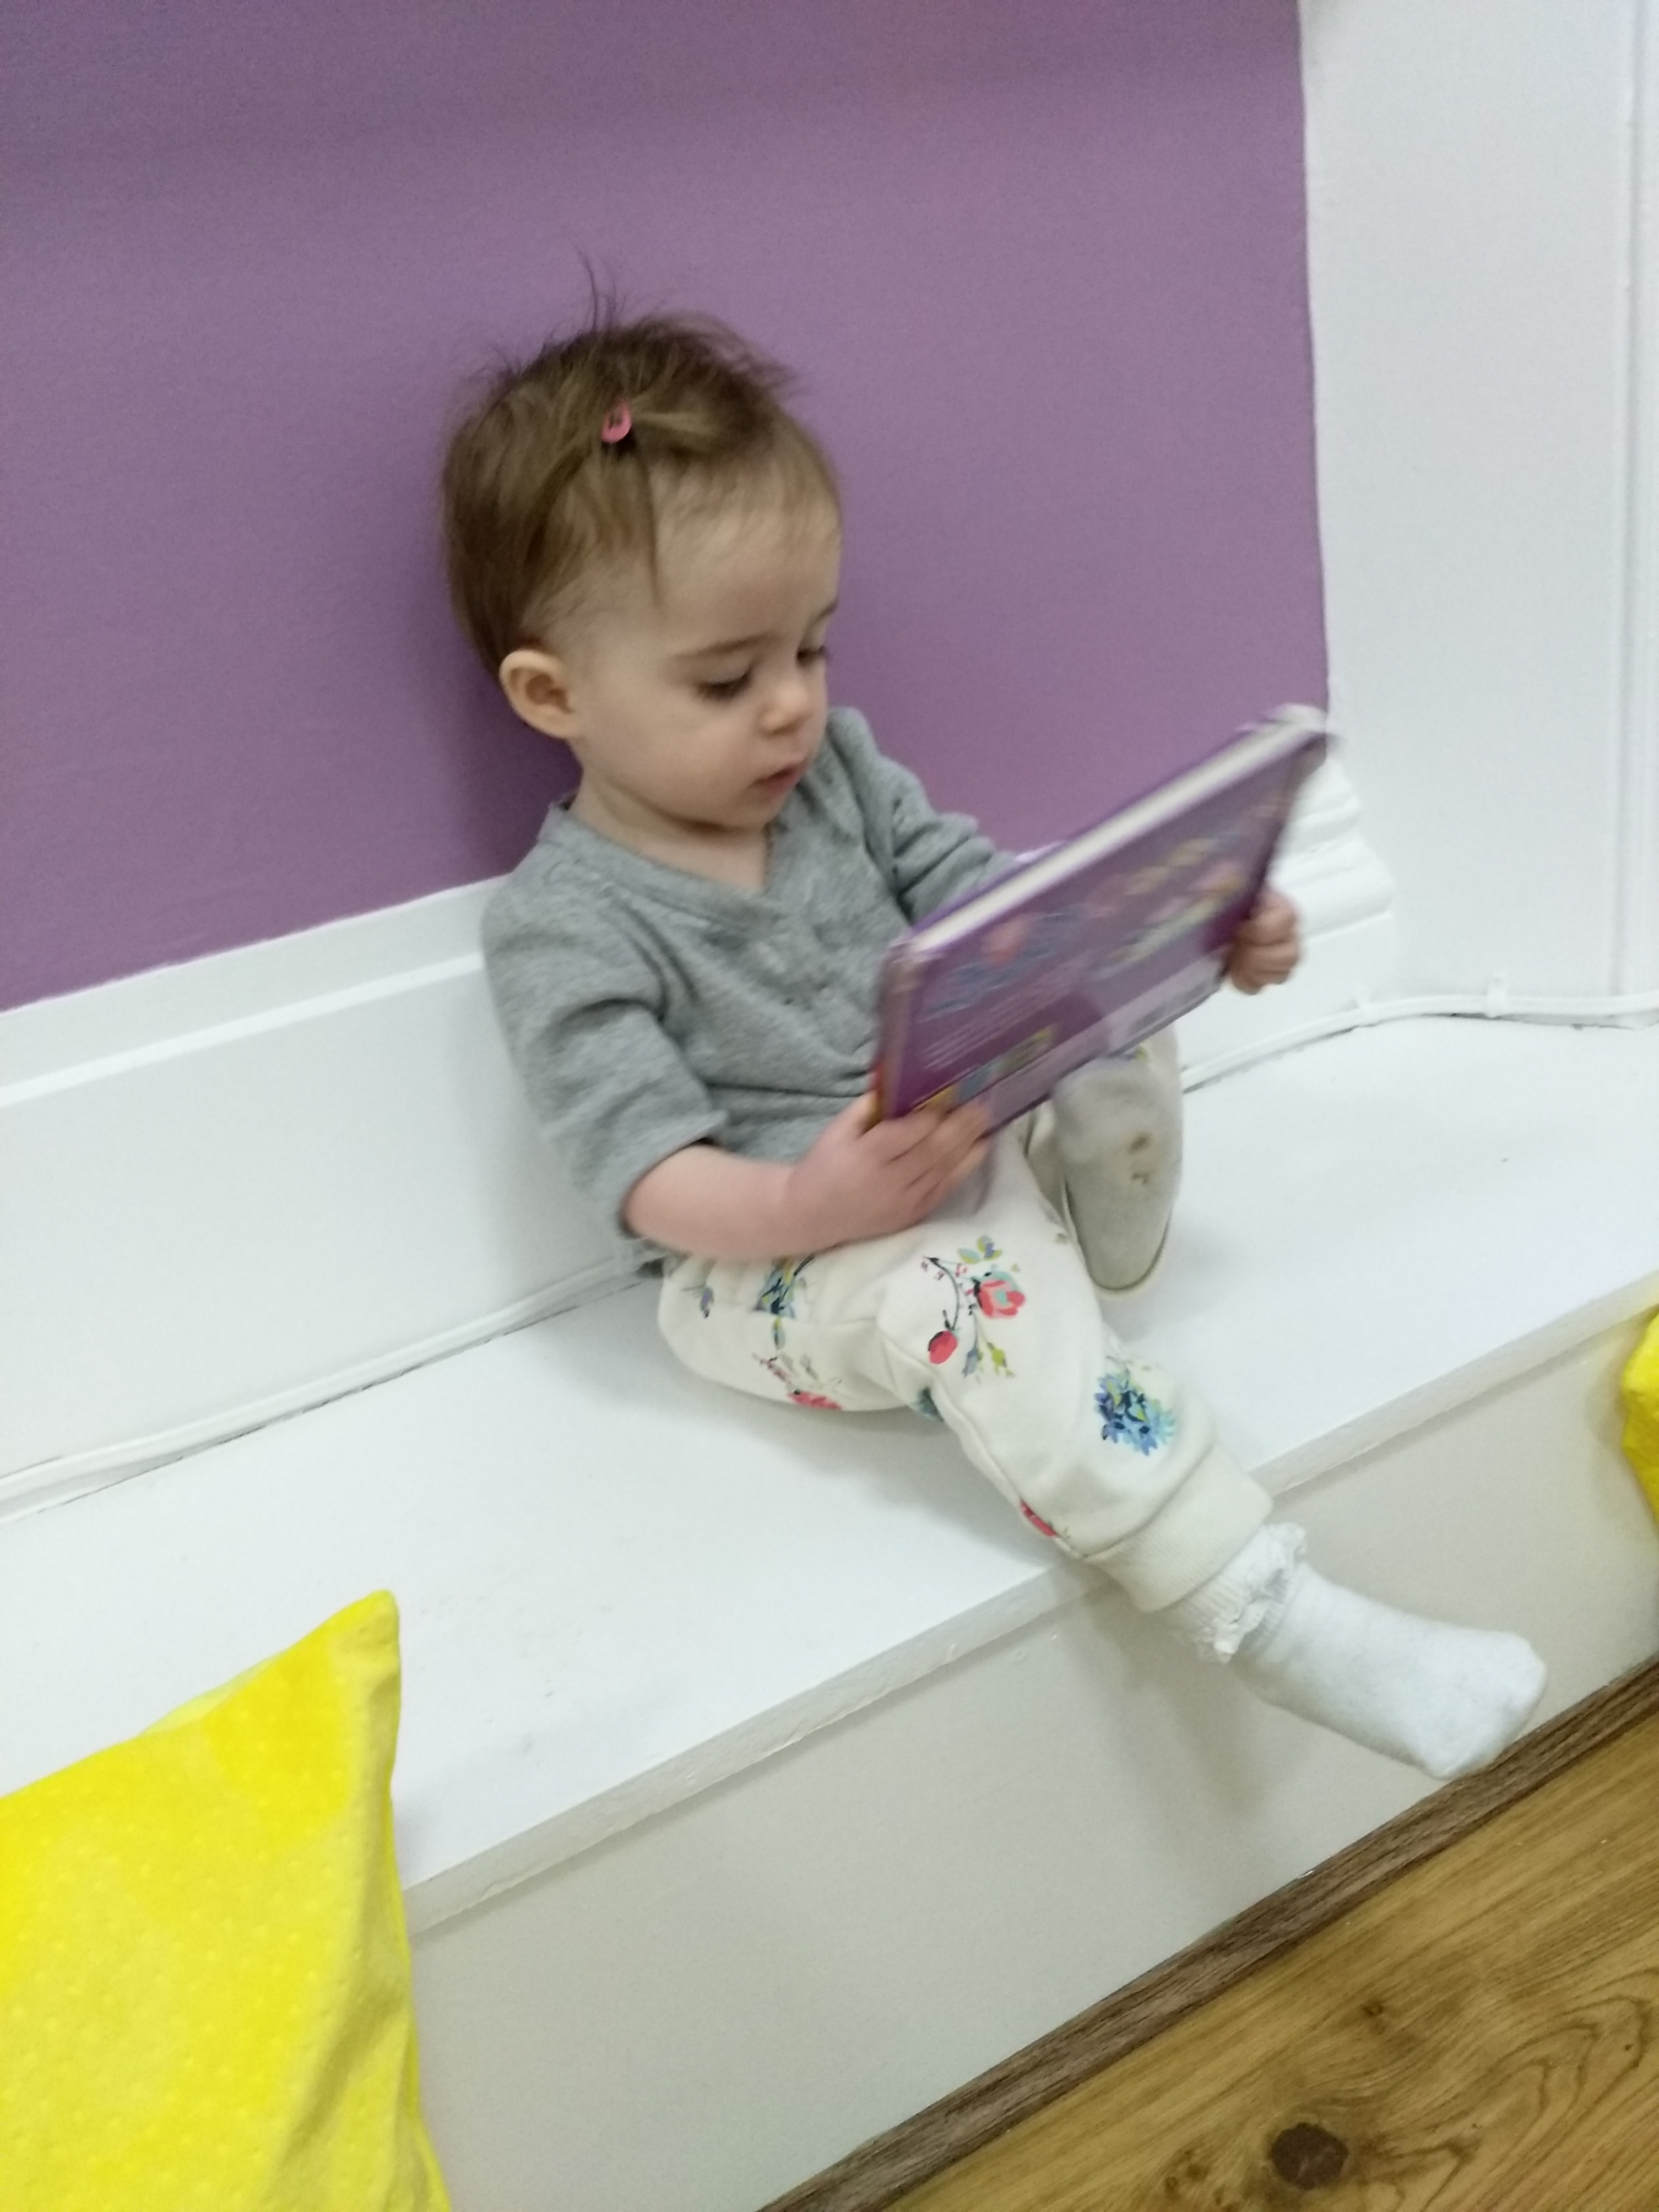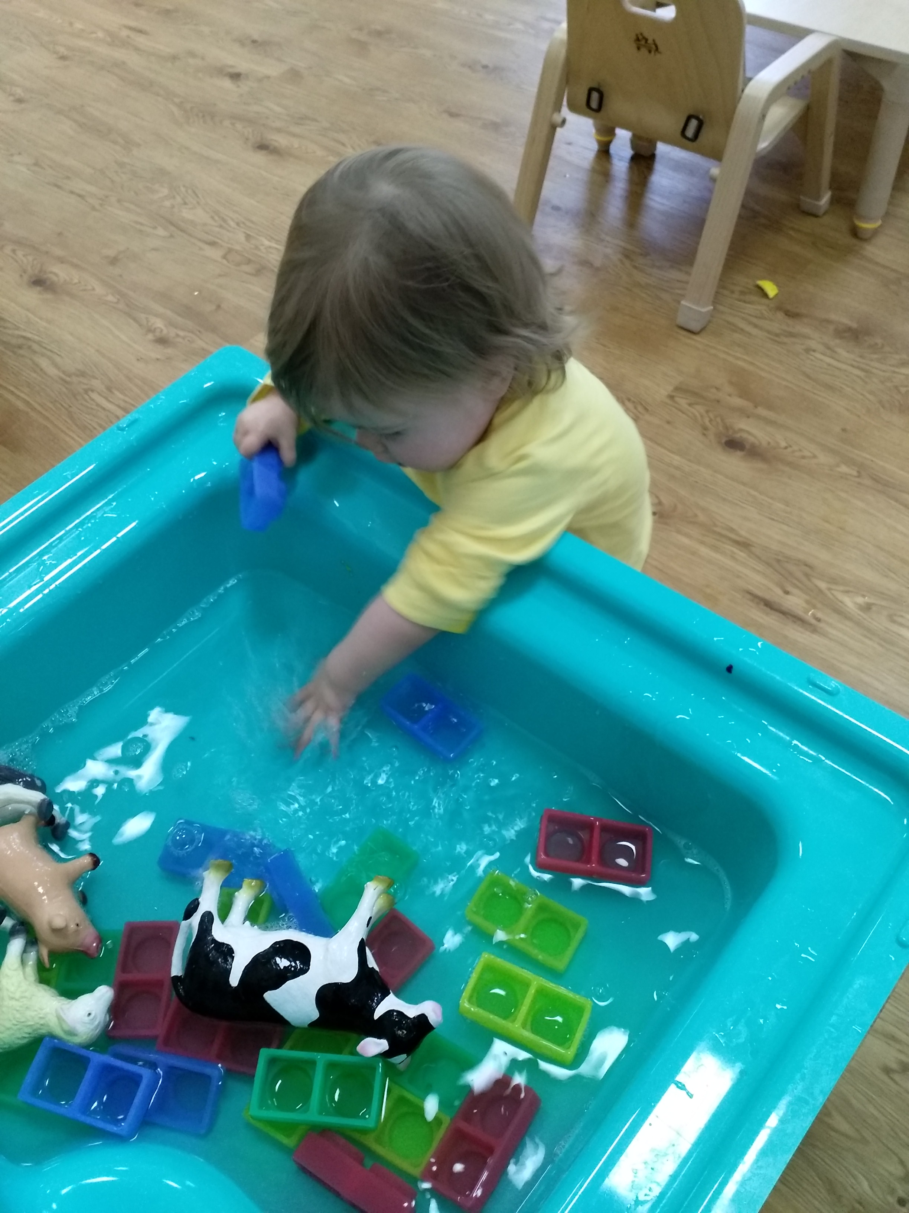

Important Reminders….. Builders are currently working onsite; they will endeavour to create as little noise and disruption as possible but please bear in mind in case of extra vehicles around and about. The builders are just finishing off all the little jobs and we are hoping to be moving down to our new room towards the end of January.
Illness: We have some nasty bugs and high temps going around – please remember if your child shows any symptoms they should be kept away from nursery until they have been symptom free for 24 hrs. Thank you for your support with this.
Tapestry: Please kindly activate your login details and check your children’s profiles which are updated regularly. Kindly add any home observations and pictures of recent travel or trips to show parent partnerships. This learning portfolio will be shared with your child’s future school.
We value and appreciate our strong relationships with parents and guardians. Thank you all for your continuous support. We have an open-door policy and would welcome any comments and suggestions
Thank you Jane, Maria and Walton staff team.







