Week 1
Monday | Tuesday | Wednesday | Thursday | Friday
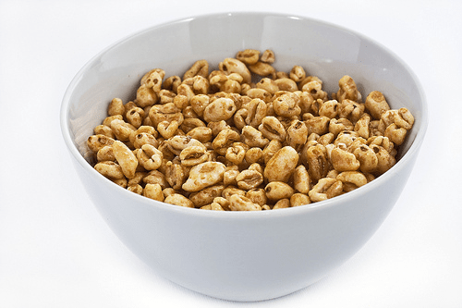  Breakfast  A selection of cereal and toast | Breakfast  A selection of cereal and toast | Breakfast  A selection of cereal and toast | Breakfast  A selection of cereal and toast | Breakfast  A selection of cereal and toast
AM snack - 3 different fresh fruits or vegetables to be offered in the snack shop
Lunch  Salmon and Pea Risotto  Carrots  Quorn and Pea Risotto  Yogurt and Fruits | Lunch  Pasta shapes Vegetarian Bolognaise  Chocolate Cracknel (milk drink) | Lunch  Sweet potato and spring onion swirls with spicy wedges and mixed vegetables  Banana muffins with custard | Lunch  Roast Chicken with roast potatoes cauliflower, carrots and parsnips  Chocolate sponge and chocolate sauce | Lunch  Fish fillets homemade chipped potatoes and sweetcorn  Apple tart and Ice cream
PM snack - 3 different fresh fruits or vegetables to be offered in the snack shop
Tea  Tuna and cucumber mayo sandwiches  Cucumber sticks  Biscuits | Tea  Cheese wraps with carrot sticks  Peaches in Jelly | Tea  Beans on toast  Fruits and cookies | Tea  French Bread Pizza  Yogurt and Bananas | Tea  Bread Rolls with Turkey Ham or cream cheese  Fruits

Monday | Tuesday | Wednesday | Thursday | Friday
Breakfast  A selection of cereal and toast | Breakfast  A selection of cereal and toast | Breakfast  A selection of cereal and toast | Breakfast  A selection of cereal and toast | Breakfast  A selection of cereal and toast
AM snack - 3 different fresh fruits or vegetables to be offered in the snack shop
Lunch  Lemon and pepper chicken country style potatoes  Lemon pepper Quorn  With Mixed Vegetables  Flapjacks | Lunch  Beef or Quorn and Spinach curry  with rice and Carrots  Fruit crumble with custard | Lunch  Roast Chicken or Quorn Fillets, roast potatoes with peas, carrots and Gravy  Raspberry Buns | Lunch  Loaded vegetables pizza with home baked chips and peas  Peaches and custard | Lunch  Homemade fish fingers in breadcrumbs  Carrot cake
PM snack - 3 different fresh fruits or vegetables to be offered in the snack shop
Tea  Spinach and cheese muffins with cherry tomato  Fruit platter | Tea  Tomato soup and Roll  Apple and Pears | Tea  Pitta Bread with hummus and cream cheese  Yogurt and Fruit | Tea  Quorn sausages in a roll and Tomato wedges  Fruits in Jelly | Tea  Cheese Sandwiches  Biscuits and Milk
Week 2

Monday | Tuesday | Wednesday | Thursday | Friday
Breakfast  A selection of cereal and toast | Breakfast  A selection of cereal and toast | Breakfast  A selection of cereal and toast | Breakfast  A selection of cereal and toast | Breakfast  A selection of cereal and toast
AM snack - 3 different fresh fruits or vegetables to be offered in the snack shop
Lunch  Chicken korma pasta with Tomato sauce  Butter scotch Crunch | Lunch  Macaroni cheese with peas  Semolina and Raspberry colis | Lunch  Roast Chicken, Roast potatoes, cauliflower and carrots/vegetarian meatballs  Iced Sponge and milkshake | Lunch  Sweet and Sour Tofu Noodles  Pineapple and Toffee Sauce | Lunch  Haddock and cod Fish pie with Homemade chips and peas  Ginger Cookie and milk
PM snack - 3 different fresh fruits or vegetables to be offered in the snack shop
Tea  Pizza with carrots and cucumber batons  Ice Cream with Mini biscuits | Tea  Toasted crumpets and Beans  Yogurt | Tea  Cheese or ham bagels  Fruit salad | Tea  Sausage in Rolls  Banana Bread | Tea  Chicken or Cheese Sandwiches  Apples and Pear wedges

