Spooky Friday News
25th October 2019

We are very excited to let you know next week on Wednesday 30th october we are having Halloween party . So please dress up your child as Halloween theme. We will suggest child friendly dressing up outfit as children can be stressed to observe scary outfit . We will also have Halloween Lunch on the same day on 30th,Our menu is
Ghostly Pizza, Blood Beans, Jelly Goo & Pumpkin pie
We will curve pumpkin and make our own spider on Monday , on Tuesday we will decorate biscuits and cakes to take home. We are also in the process of making haunted house with Adeer. We will play inside the haunted house through out the week.
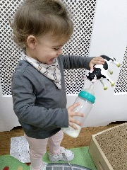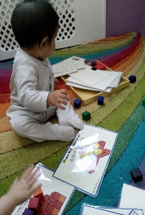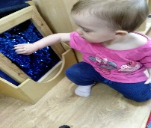
This week ELM class have been busy pretending play at the home corner , exploring montessori sensory areas at our preschool.They have been spending some time with the preschool children, they have enjoyed the company of the older children. The babies have really enjoyed doing some song and rhymes time and playing musical instruments. In Oak class we have been making our haunted house. In our Language lessons we have been learning lots of new words in French lesson we are practising last weeks word Triste (sad) and heureux (happy). 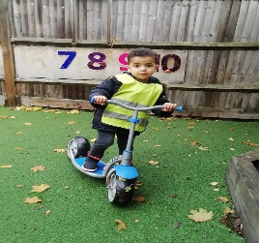 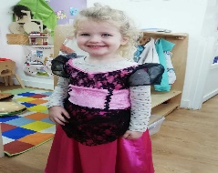
We were enjoyed dressing up at the home corner and our new child Hamza settle in very well. His favourite learning area is outdoor play area. Thank you to all the parents for being with us and I hope you will all have a great half term with your older children and manage to get out into the countryside to enjoy this colourful season.

