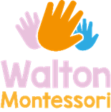 **We have been very busy using our creative skills to make rockets, cars, space ships with boxes also we have begun to make a large space ship, working together as a team building our vocabulary and expressing our ideas to build our space ship. We have chosen to paint it also using a mixture of colours and finding out that when we mix two colours together they make new colours.**

**Friday News 20th September 2019**

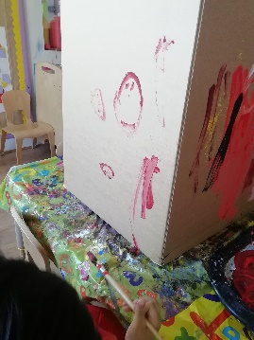 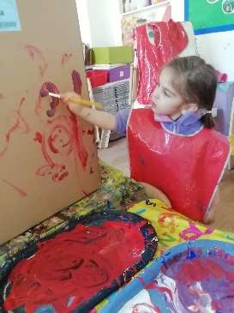 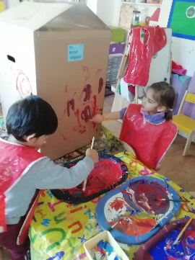 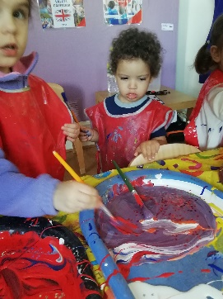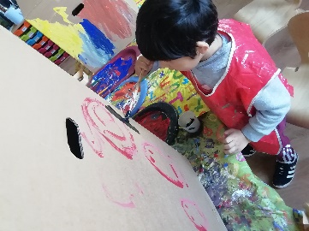

**At forest school this week we have been busy remembering the rules around keeping safe at forest school, listening to the world around us and discussing what we can hear. Also we have been very imaginative making a chocolate farm, pancakes and cupcakes along with a pirate ice cream shop and a band using saucepans and lids.**

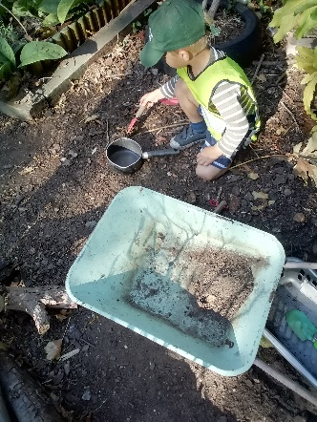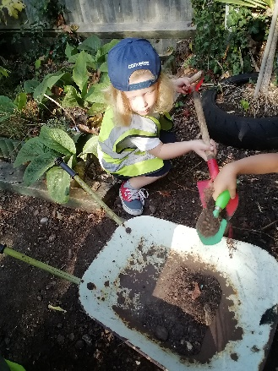

***Extra activities we are doing: Forest School Maria will be doing throughout week, Livia will be doing Spanish class on a Thursday, Khouloud will be doing Arabic class on a Monday, Khouloud will be doing French class on Friday.***

**Next day we will be finishing of our giant Space Rocket, also from the interest of the children we are going to look at text in our environment from packaging (parents please could you collect any packaging that you use such as Quorn, Kellogg’s, Birds eye etc. to start making our alphabet using these) Thankyou in advance.**

**Have a lovely Weekend and we will see you all on Monday for lots of learning.**