Friday News 13th September 2019
We have been very busy this week playing with Autumn leaves and doing wide varieties activities related to Autumn. Children were collecting different coloured leaf from the outdoors and discussing the different colour between them.
We have also made our own fairy land in the garden with lots of shiny collages and we did sticking activities with shiny sequins, coloured feather and pompom .
Our new babies are very happily settling in. James and Eva have had their first week and was very keen to explore all community play areas . Eva’s favourite area was cosy sensory area. She love playing peekaboo in our cosy area. James likes to try walking around the room by holding adult’s hand. Georgina was very independent at her settling session.we are really looking forward to having her next week. Sophia is our youngest baby (7 month’s old) and she had one settling session this week. I would like to invite all existing parents who have baby to arrange a play time in our baby room. We are offering one-hour play time to our existing parents so they have more in depth idea about the varieties activities we offer for babies. This is the offer only for existing parents.
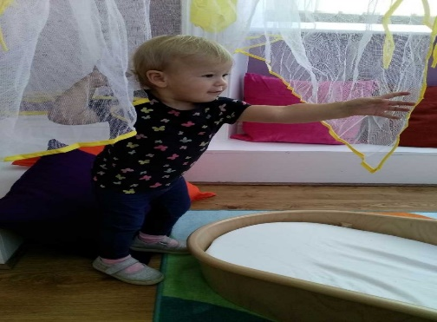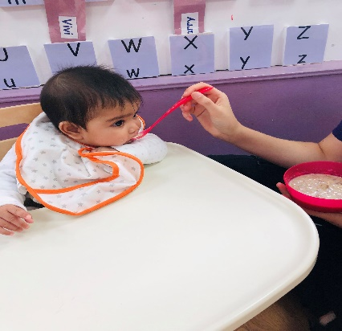
Please let us know if your child is interested to play ball please speak to Gareth if you would like to book.
Can we remind again to send us your photo to update children’s folder.
This week the children have been really interested in making junk modelling. Next week we all will be making space ships /stars/moons/suns/different planets with different junk model and we will be discussing the newly discovered planet where scientist believes people can inhabit. WELCOME TO Georgina in our baby room and Delilah in our Oak room. Have a lovely week end, see you all Monday.

